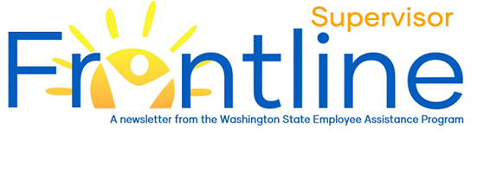
Not everything that is faced can be changed, but nothing can be changed until it is faced – James Baldwin

Supporting the Workforce During Transitions
In this month’s newsletter:
Supporting Employees During Transitions
Upcoming EAP Live Webinars
Articles
Resources
Contact EAP
eap.wa.gov
Toll free: (877) 313-4455
Phone: (360) 407-9490
Interpreters available.
TTY: call 711 via WA Relay

A Time of Transition
Over the course of the past 15 months, we have become deeply familiar with change and transition. Multiple crises – the pandemic, civil unrest, wildfires, political strife and violence in our communities – have disrupted entire ways of living, loving, working and playing. All the while, our hearts and minds have been hosts to a dizzying range of thoughts and emotions.
And now, as the rates of COVID infections and COVID-related deaths fall and as pandemic-related restrictions are lifted, we again face heightened uncertainty, change and transition.

Change vs. Transition
The terms change and transition are often used interchangeably, but they each have distinct meanings – meanings that can inform efforts to support the workforce. According to William Bridges – author, speaker and organizational consultant - change is what happens to individuals, while transition is the process individuals experience as change happens.
Like spring and summer 2020, this summer and fall promise change. Mask requirements, hybrid work environments, work locations and work relationships will – for many – undergo significant change. Each employee will have their own unique way of experiencing the coming changes.

What to Expect
Every person responds to and copes with change in unique ways. Change can be a motivating and exciting force for some, while others might experience negative emotions. Change can cause feelings of eustress – a form of stress that motivates and challenges us. Eustress can feel exciting, as we face challenges that seem within our capabilities. Change can also cause distress – a form of stress that can cause worry and anxiety and feels unpleasant and unwelcome. Distress can feel overwhelming and impede performance. Given the coming changes, we all should expect to see a range of emotions and behaviors in the workplace, including:

- disbelief
- anger
- sadness
- worry and anxiety
- avoidance
- excitement
- anticipation
- impatience

Employees will also exhibit of range of behaviors. Some might become more vocal and demanding, while others might be quieter and conflict-avoidant. A few employees might more readily and openly engage in confrontations and conflict. Expect a temporary decline in productivity for some and an increase errors for others.

What You Can Do
- Model positivity and confidence: Positivity and confidence can be inspiring and contagious. Negativity and doubt can impede problem-solving, while also instilling fear.
- Communicate: Focus on values, mission and goals. Identify and review expectations. Talk about what is and isn’t working. Allow for questions and feedback.
- Normalize: Help employees understand that their thoughts and feelings are reasonable and to be expected, given the many crises, changes and transitions they have faced over the past year.
- Practice compassion and empathy: Show your employees you care for them and that you understand, feel and share in their emotional experience.
- Offer, provide and obtain support: Let us help you and your employees get connected to helpful and supportive resources. The Washington State EAP is a great place to start.
- Attend a WA State EAP live webinar: See below for EAP’s latest live webinar offerings.
- Attend an instructor-led workshop in fall 2021: This fall, Workforce Learning and Performance (WLP) plans to offer Leading Remote and Hybrid Teams. In this virtual instructor-led workshop, supervisors will learn best practices for leading remote and hybrid teams as well as brainstorm new ideas with their peers. Workshop information and registration information will be coming soon.

Upcoming EAP Live Webinars
To register for EAP Live Webinars, visit EAP’s Webinars. Registration for the below webinars should open by Thursday, July 1, 2021.

Transitioning into the New Work Life: Creating Psychological Safety in Work Teams
This webinar is intended for leaders (supervisors, managers, HR, and anyone else in a leadership role)
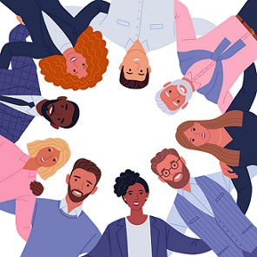
Many employees are experiencing stress, worry, and uncertainty as we transition into a work environment which has changed with the pandemic. As a leader, you may be wondering how to best support your workgroup and how to navigate the transition back to the workplace.
In this webinar you’ll learn about:
- the importance of creating psychological safety as a leader,
- multiple strategies to build psychological safety in your workgroup, and
- the supports and resources that are available to both you and your employees.

Transitioning into the New Work Life: Strategies for Responding to Change
Over the past year plus, we’ve faced challenges we never could have imagined prior to March 2020. As our State continues to open up, you may find yourself experiencing uncertainty, stress, and a mixture of emotions.
In this webinar we’ll:
- reflect on the past year,
- identify possible stress responses,
- talk about the natural psychological process we move through in response to change,
- offer strategies to help you manage your way in this new work life, and
- provide information on resources and supports available to you.

Articles
- Coping with Work Transitions, Be Well, Stanford University
- Managing Someone Whose Life Has Been Upended, Harvard Business Review
- Managing Fears of Re-entry, CNN Health
- How to Rally a Jittery Workforce Back at the Office, The Wall Street Journal
- How Positive Leadership Shapes Positive Organizational Behaviors, Forbes
- Types of Stressors (Eustress vs. Distress), MentalHelp.net

Resources
- Healthy Washington – Roadmap to Recovery Guide, OFM
- COVID-19 Return to Work Playbook, Kaiser Permanente

